An Intelligent Tutoring System for Japanese Language Particles with User Assessment and Feedback

Zachary T. Chung

Ateneo de Manila University  
Department of Information Systems and Computer Science (DISCS)  
Katipunan Ave., Loyola Heights, Quezon City, Philippines  
+63-2-426-6001 local 5660

zachary.chung@obf.ateneo.edu

Hiroko Nagai, Ph.D.

Ateneo de Manila University  
Japanese Studies Program (JSP)  
Katipunan Ave., Loyola Heights, Quezon City, Philippines  
+63-2-426-6001 local 5248

hyabut@ateneo.edu

Ma. Mercedes T. Rodrigo, Ph.D.

Ateneo de Manila University  
Department of Information Systems and Computer Science (DISCS)  
Katipunan Ave., Loyola Heights, Quezon City, Philippines  
+63-2-426-6001 local 5660

mrodrigo@ateneo.edu

**ABSTRACT**

In recent years, an increasing number of Ateneo students have been taking an interest in the Japanese language. For Ateneo students beginning their study of the language however, Japanese particles are difficult concepts because they cannot be translated to equivalent words in English. For a beginner learner, it is inevitable to view a second language with the lens of a first language as shown by the concept of transfer in second language acquisition. As a result, learners tend to misconstrue Japanese particles by attempting to understand them with respect to non-existent equivalents in English.

In this research, we develop an intelligent tutoring system for Ateneo students taking introductory Japanese (FLC 1JSP) to aid them better understand Japanese particles. The system would assess the learner’s understanding of Japanese particles by practice and depending on which particle where most mistakes are made, the system would give instructional feedback. Feedback to be implemented in the system use visual prototypes that represent the meaning of the particle. We hope to see if visual representations can also teach Japanese particles to students as an alternative to text-detailed explanations such as those commonly found in textbooks.

**Categories and Subject Descriptors**

K.3.1 [**Computer Uses in Education**]: Computer-assisted instruction (CAI), Distance learning

**General Terms**

Design, Experimentation, Human Factors, Theory

**Keywords**

Intelligent Tutoring Systems (ITS), Japanese particles, Case Particles, Japanese language, Visual prototypes

# INTRODUCTION

# 1.1 Context of the Study

An increasing number of Ateneo students are minoring in Japanese Studies to learn more about the Japanese language and culture. Students beginning Japanese in their FLC 1JSP (Introduction to Japanese) course encounter difficulty with Japanese particles regarding proper usage and context: に (ni)、へ (e)、を (wo)、と(to)、で (de)、の（no）、は（wa）、が（ga）

# 1.2 Research Objectives

In this paper, we discuss the development of a web-based Intelligent Tutoring System (ITS) addressing the difficulty of Ateneo students with Japanese particles - a system that facilitates practice with feedback that clarifies particle usage and meaning. We attempt the following questions:

1. How do we create an intelligent tutoring system for Japanese to help students better understand the concept of Japanese particles?
2. Other than the topic and subject marking particles は(wa) and が(ga) respectively, which particles do students make the most mistakes with in FLC 1JSP?
3. What do these errors imply about the student’s mental model of Japanese particles?

# 1.3 Scope and Limitations

Users of the system developed are primarily FLC 1JSP students of Ateneo de Manila University, hence system content is scoped to the said course. We aim to supplement the language knowledge of FLC 1JSP students; instruction in the system is geared towards clarifying understanding, as opposed to teaching anew.

Finally, we utilize visual feedback in the system based on prototypes by Sugimura (discussed in section 2.1) because we like to know if Japanese particles can also be taught by animations aside from explanations of their meaning. For particle and word combinations that do have not have any visual representations, we use textual feedback based on Socratic questioning as our alternative form of feedback. We hope to see if computer animations and our combination thereof can be an effective means to clarify these Japanese particles to students.

# FRAMEWORK

# 2.1 Visual Prototypes for Japanese Particles

Japanese particles can be taught using images representative of their meaning. Sugimura demonstrates that each Japanese particle can be represented by a prototype image and he states that learners would have less cognitive load learning Japanese particles in this manner than rote memorization of a definition [11]. In this research, we develop visual feedback, based on five prototype images of the following particles from FLC1 JSP: **ni, e, to, no, de**.

1. The particle **ni**

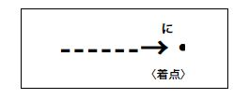

Figure 2.1: Prototypical meaning of ni [11]

**Ni** shows the directionality of an agent’s action and its binding effect to a target [11]; **ni** can also indicate the place or time of existence of a subject [11]. These two usages are generalized into the image of a point, indicating a destination or a point in time shown above. Compared to **e**, **ni** emphasizes the destination as opposed to the process, depicted by the dotted arrow in figure 2.1.

1. The particle **de**

The particle **de** indicates *space* where an action takes place in the nominative or accusative case [11]. The prototype of this particle is shown in figure 2.2 below:

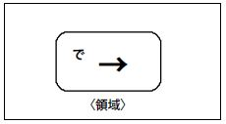

Figure 2.2: Prototypical meaning of de [11]

The arrow in figure 2.2 above represents some force acting within an enclosed space. Though **de** is likewise represented with an arrow like **ni**, **de** emphasizes an action performed within the bounds of a certain space [11].

1. The particle **e**

In essence, **e** is similar to **ni** for indicating the direction of an action. Compared to **ni**, **e** puts emphasis in the process or means of an agent to get to a destination [11; Dr. Hiroko Nagai personal communication, May 5, 2012]. The particle **e** is represented according to Sugimura in figure 2.3 below [11]:

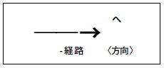

Figure 2.3: Prototypical meaning of e [11]

1. The particle **to**

According to Morita, the particle **to** has a unificative meaning associated to its usage [11], where two agents work together to perform an action. In a prototype image, Sugimura depicts the meaning of the particle **to** as follows [11] (Refer to Figure 2.4):

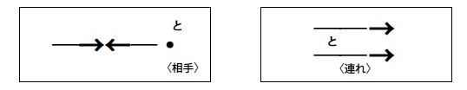

Figure 2.4: Prototypical meaning of to [11]: An action performed together in companionship.

1. The particle **no**

**No** denotes relations between nouns but these have various forms hence, we only consider **no** for the following usages in our research as scoped in FLC1 JSP:

1. A is the possessor of B (like the B of A or A’s B) such as: watashi **no** kaban (My bag)
2. A is the location where B belongs to (B in/at A) such as: ateneo **no** gakusei (A student in Ateneo) and;
3. A created B hence B is possessed by A such as: gakusei **no** sakubun (A student’s essay)

In all these three cases above, the particle **no** connects nouns together, such that the preceding noun phrase forms a phrase to modify a following noun phrase [6]. According to Oya, Japanese language adviser of the Japan Foundation, Manila, the particle **no** can be depicted in a prototypical image of a circle (noun 2) inside a larger circle (noun 1) and so on as follows for these three usages:

Figure 2.5: Firipin no ateneo no daigakusei: Combining nouns with no

In figure 2.5 above, the largest circle sets a scope to the circle(s) enclosed within. In this representation, Ateneo is in the Philippines and the student is affiliated with the Ateneo, thus a set of concentric circles. The enclosed nouns are connected by **no,** forming one noun, meaning “A University Student of Ateneo in the Philippines”.

# 2.2 Visuals as Feedback in Multimedia Learning

Students learn best by seeing the value and importance of information presented so it is important to sustain interest using a feedback medium that coincides with the learning style of a student, which is “the manner in which individuals perceive and process information in learning situations” [4].

According to the Cognitive Theory of Multimedia Learning by Mayer, Multimedia instructional messages designed according to how the human mind works are more likely to lead to meaningful learning than those that are not [7]. The theory states that humans seek to make sense of multimedia presentations in relation to their collected experiences. Hence, visual feedback would be effective given that it resembles common human experience while depicting the meaning of Japanese particles. Table 3.1 summarizes the theory regarding how learners relate visuals to experience.

Table 3.1 Image-related Processes in the Cognitive Theory of Multimedia Learning: Building Connections between Pictorial Models with Prior Knowledge

|  |  |
| --- | --- |
| **Process** | **Description** |
| Selecting images | Learner pays attention to relevant pictures in a multimedia message to create images in working memory. |
| Organizing images | Learner builds connections among selected images to create a coherent pictorial model in working memory. |
| Integrating | Learner builds connections between pictorial models and with prior knowledge. |

As guidelines for our design of visual feedback, the following are prescribed by the theory [1, 2]:

1. **Focus on Task-Relevant Aspects of Information:** Research show that guiding learners' attention is only useful if it leads the learner to a deeper understanding of the task-relevant parts of the information presented.
2. **Limit Unnecessary Information:** Each piece of information, useful or not has to be processed by the learner so it is additive to cognitive load. According to the Apprehension Principle, information that is not required for the task or problem solving, such as seductive details or eye-catching illustrations, produce extraneous cognitive load that ties attention to less relevant concepts and therefore reduces knowledge acquisition [1].
3. **Attention-guiding Principle:** Supporting the process of selecting relevant information will be useful because it shifts the learners' attention to those parts of information that are needed to understand the key concept of presented materials. Also, since animation is fleeting by nature, often involving simultaneous display changes, it is important to guide learners in understanding the animation so that they do not miss the change. Highlights, visual cues and color coding seem to be appropriate visual instructional aids because novice learners are not able to distinguish between relevant and irrelevant features.
4. **Personalize Instruction:** Learner's attention can be activated in a more effective way if instructions are personalized rather than anonymous, for example by addressing the learner in the first person.

# 2.3 Error Isolation and Feedback

Mistakes are part of the learning process. According to Gass and Selinker, second language errors do not reflect faulty imitation by a learner; they are attempts to figure out a system by imposing regularity on the language being learned. In fact, mistakes are structured; there is an underlying generalization and this shows a certain level of development [3, 9].

Mistakes are akin to slips of the tongue but errors are systematic and recurring [3]. Errors mean that the learner does not recognize that it is wrong, and by consistent reproduction, he has incorporated it into his system of the target language [3]. In our system, we isolate errors by a pre-test and when an error has been committed at least twice (same particle and context), then feedback is given, targeting the faulty knowledge only as much as possible.

Feedback in our system is designed to let the learner realize his own mistake. We do this by presenting the animation of a learner’s erroneous particle side-by-side with the animation of the correct particle. Alternatively, we pose questions or hints to challenge the learner to reconsider his answer instead. In this manner, we allow the learner an opportunity to explore and adjust the application of the form or rule he used to derive his wrong answer to what is correct – *restructuring* in interlanguage processes [9]. This is more effective because it does not interrupt the learner because of fear of being directly corrected [5].

# METHODOLOGY

# 3.1 Development Methodology

The Intelligent Tutoring System (ITS) developed in this research is web-based for simpler deployment and testing; Adobe Flash was used to drive animations.

Figure 3.1: The Prototyping Methodology [8]

Based on consultations with FLC 1JSP instructors, students have difficulty mastering case particles because they confuse the different notions these particles provide in sentences. We identified particle pairs students frequently have misconceptions with such as **ni** and **de**, **to** and **no** or **ni** and **to**, etc., then we developed prototype animations that highlight their semantic differences. Then, we showed these animations to instructors for feedback and we improved them to ensure that visual feedback developed in any form teach the correct notion of Japanese particles. Consultations were performed during development mainly with Dr. Hiroko Nagai, Director of the Ateneo Japanese Studies Program, as well as with Mr. Susumu Oya, Japanese Language Adviser of the Japan Foundation, Manila, observing the processes of the prototyping methodology in software development as shown in figure 3.1 above.

## 3.2 Student Modeling

Student models provide descriptions of learning at a level of granularity that facilitates the encoding of principles and rules in a teaching system [12]. Learner models approximate student behavior by tracking misconceptions in comparison with substandard reasoning patterns. This is performed with the goal of supporting weak students’ knowledge and to develop the students' strengths [13]. In our system, we used an overlay model to model the student-user of our system. The model is able to show “the difference between novice and expert reasoning, by indicating how students rate on mastery of each topic, missing knowledge and which curriculum elements need more work" [13]. Since an overlay model is a model of a proper domain subset (i.e. Japanese particles in grammar), we used this model to evaluate students and give feedback accordingly.

The disadvantage of overlay modeling is that students may have knowledge that is not part of an expert’s knowledge, thus it is not represented in the student model [13]. However, we mitigate this by creating a multiple-choice based system, where possible answers are contained only within the domain knowledge we teach. Since Japanese particles also have distinct grammatical usages at the level of FLC1 JSP, creating this model is simple because the domain knowledge itself is a matter of conforming to concise grammar rules.

To create the overlay model of the student, we broke down the concept of Japanese particles from FLC1 JSP into its base knowledge components[1]. Among Japanese particles, this is the production rule learned and referenced by a learner to know how to use a Japanese particle. For example, a student can have the following knowledge component: “to indicate the existence of a living or non-living thing, the particle **ni** is used”. In total, we have nine (9) knowledge components in our ITS, following a permutation of nine possible contextual usages of all the Japanese particles in our system designed for FLC1 JSP. Note that the particle **e** and the particle **ni** for indicating a place where something moves (direction) are both singly counted as one knowledge component, whereas the rest are considered as individual knowledge components. This is because FLC1 JSP does not yet teach students to differentiate the nuance of both these particles. Also, a more detailed description of how our overlay model operates is discussed below, where we also describe the general operation of the system.

# General ITS System Operation Flow

Students create an account and the ITS presents a pre-test called “Learning Check 1” (See Figure 3.2). This activity shows a battery of eighteen (18) Japanese sentences using the Japanese particles taught in FLC1 JSP; the task for the student in this section is to complete the sentence by choosing the right particle to complete the statement.

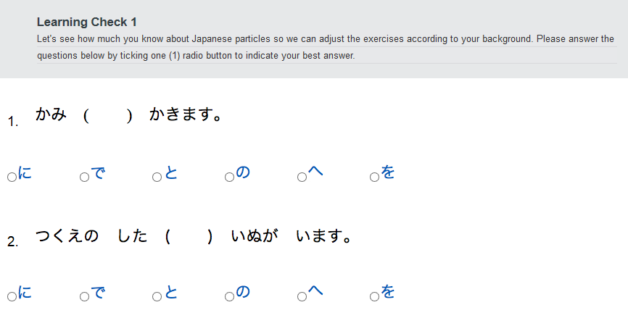

Figure 3.2: Learning Check 1 – Students complete the sentences by supplying the missing particles using the choices provided.

Learning Check 1 is used by the system to create an overlay model of the student. This is used to measure the extent of a student’s knowledge of Japanese particles. The model works by assigning points per knowledge component[2] and if a student uses a particle given a context correctly, one (1) point is assigned to the corresponding knowledge component. The model works like a table, where we distribute points across rows and each row is a knowledge component. At the level of FLC1 JSP, since we have nine (9) contextual usages for the particles taught in the course and we have two questions for each usage, we have eighteen (18) questions for Learning Check 1 (See figure 3.3 below):

|  |  |  |
| --- | --- | --- |
| **Pseudo-Overlay Model** | | |
| **Particle** | **Context** | **Pts.** |
| Ni | Indicate a point in time something takes place. | 2 |
| Indicate a place where something or someone exists. | 2 |
| Indicate target of an action by an agent (uni-directional target). | 2 |
| ni/e | Indicate a place towards which something moves. | 2 |
| De | Indicate where an event/action takes place. | 2 |
| O | Direct objects | 2 |
| No | Noun phrase modification to indicate property | 2 |
| To | Connect nouns together ‘AND’ | 2 |
| Indicate target of an action by an agent (bi-directional target). | 2 |
| **Total** | | **18/18** |

Figure 3.3 Overlay Model: Point distribution across knowledge components. Maximum attainable score is 18/18

Based on the model, the system displays content in the following section, “Learning Check 2”, where actual tutoring takes place. Here, another battery of Japanese sentences is *selectively* presented about the Japanese particles the student appears to have a lack of knowledge with, had the student not met the established minimum number of points per row of the overlay model. While the student is answering, tutoring is now provided - feedback is presented on-the-fly upon mouse clicks in Adobe Flash (See Figure 3.4):

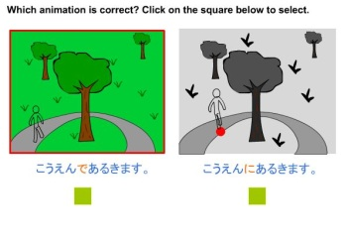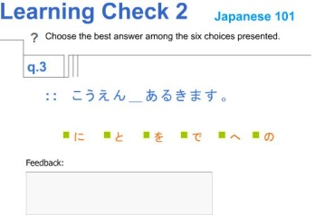

Figure 3.4: Learning Check 2 shows another sentence using ‘de’; feedback as needed.

Following Learning Check 2, we present the student a post-test to measure improvements in knowledge. The post-test also serves as a follow-up learning opportunity for the student and the questions used in this section are similar to the questions in the pre-test in terms of count, particle usage and presentation but arranged in a different order. We simply changed the nouns or verbs in the sentences and we also maintained two questions per context, hence also making eighteen (18) questions. This allows for comparison on an equal basis between both sections in terms of scoring. Also, to mitigate the possibility that the pre-test is more difficult than the post-test and vice-versa, we also swapped the questions we used in the pre-test with those in the post-test at random. Finally, after using the system, we show a report page to the student concluding the use of the system and how many points were earned based on the overlay model[3]. We also suggest grammar points to the student where more review is recommended based on the result of the post-test (See Figure 3.5 below).

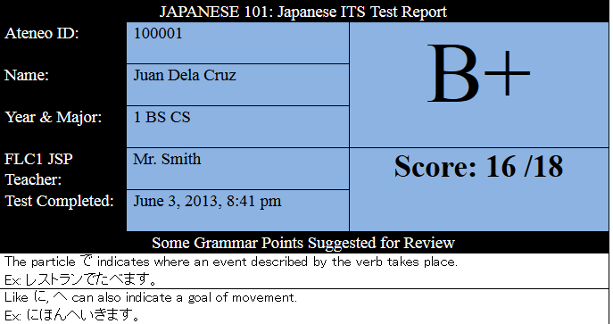

Figure 3.5: Report Page

# 3.3 Feedback Design

Feedback is given by animations based on the prototype of Japanese particles (See section 2.1). For Japanese particles and their combinations thereof with certain words, forming sentences yielding an image-based representation, we show the student animations with the correct particle and the incorrect particle subtituted in the sentences side-by-side. The goal of this mode of presenting feedback is to allow the student to think for himself the correct answer before the system explicitly shows the answer with explanation. However, for cases non-illustratable, we used textual feedback based on Socratic questioning with cues. The system was designed in mind only to show explicit correction as a last resort because our goal is to restructure grammar knowledge in this tutoring system without being obstrusive to student motivation.

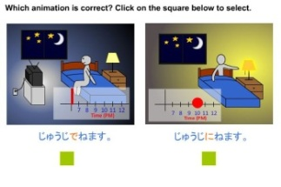

Figure 3.6: Animation Selection: With ‘de’ for the sentence “juuji _ nemasu (Sleep at 10pm).”, the animation of the incorrect answer (left) versus the correct answer (right) is shown.

If the student chooses the correct animation, he is praised and he is shown an explanation why his answer is correct. Otherwise, if the student still chooses the wrong animation, the system shows an explanation of the error and it allows the student to try completing the sentence again (See figure 3.6 below).

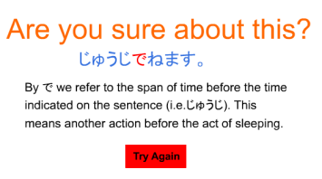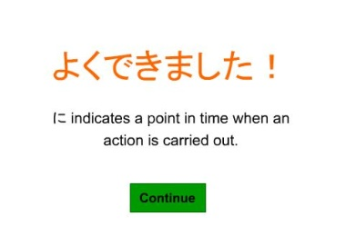

Figure 3.7 System Responses: Choosing the right animation leads to praise (left); choosing the wrong animation, leads to an explanation of the answer (right).

In cases when animations are not applicable, we give textual feedback in the form of clues based socratic questioning as shown in figure 3.7 below:

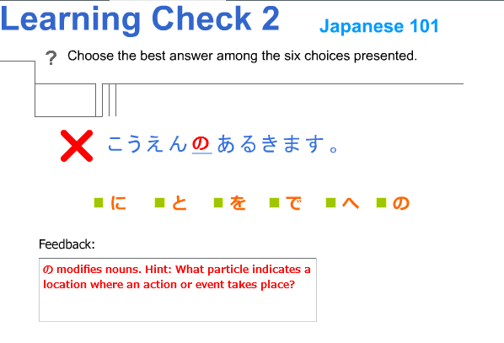

Figure 3.8: Textual feedback for syntatically impossible cases.

# Results

# 4.1 Field Testing

As a system designed to target students beginning their study of Japanese in Ateneo, field testing was conducted with the aforementioned students during their FLC1 JSP classes. Students were brought to a computer lab to access the tutoring system online and a total of forty-five (45) students participated in testing across classes handled by three different instructors.

For our results in this research, we focus on presenting analysis based on the results of our pre-test versus post-test scores to see if the students improved using our ITS. Also, we evaluate the experience of the students who used our tutoring system via survey to give us an idea how they find our ITS.

# 4.2 Testing Methodology

Participants were divided into two (2) groups: twenty-one (21) and twenty-four (24) participants respectively. One group used the ITS such that at the onset of a mistake, corresponding feedback is already shown in Learning Check 2. Another group used the ITS such that the pair of sentences per particle and its context in Learning Check 1 must be incorrect for feedback to be given in Learning Check 2. We formed the two test groups to see how much consideration is adequate before feedback is delivered, although the latter case is ideal based on the notion of error consistency from second language acquisition. A single mistake may not necessarily translate to malformed knowledge about a concept (i.e. a mouse misclick) hence, we believe that consistency is key to isolating true faulty knowledge [3]. During testing, no student was allowed to use any references regarding Japanese particles over the internet.

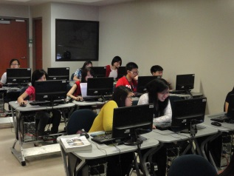 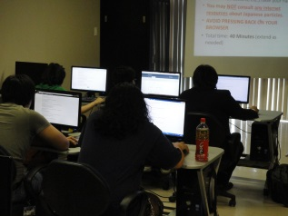

Figure 4.1: Computer Laboratory Setup

4.4 Pre-test and Post-test Comparison

|  |  |  |  |  |  |  |  |  |
| --- | --- | --- | --- | --- | --- | --- | --- | --- |
| Table 4.1: Group 1 – One mistake, then Feedback | | | |  | Table 4.2: Group 2 – Two mistakes, then Feedback | | | |
| **ID Number** | **Pre-test (18)** | **Post-test (18)** | Δ |  | **ID Number** | **Pre-test (18)** | **Post-test (18)** | Δ |
| 120864 | 8 | 9 | 1 |  | 111662 | 10 | 11 | 1 |
| 110882 | 10 | 12 | 2 |  | 114537 | 11 | 9 | -2 |
| 110966 | 8 | 4 | -4 |  | 114553 | 3 | 10 | 7 |
| 111329 | 6 | 5 | -1 |  | 121314 | 9 | 14 | 5 |
| 91388 | 9 | 13 | 4 |  | 121359 | 10 | 11 | 1 |
| 122145 | 7 | 11 | 4 |  | 124592 | 10 | 8 | -2 |
| 112807 | 10 | 11 | 1 |  | 114512 | 5 | 9 | 4 |
| 123232 | 12 | 16 | 4 |  | 110866 | 8 | 9 | 1 |
| 123653 | 8 | 10 | 2 |  | 111399 | 11 | 9 | -2 |
| 123743 | 9 | 11 | 2 |  | 91957 | 9 | 8 | -1 |
| 123796 | 9 | 11 | 2 |  | 112107 | 3 | 5 | 2 |
| 123800 | 4 | 7 | 3 |  | 112227 | 8 | 6 | 2 |
| 114162 | 11 | 12 | 1 |  | 112017 | 3 | 5 | 2 |
| 94060 | 5 | 11 | 6 |  |
| 120721 | 10 | 11 | 1 |  |
| 123283 | 9 | 9 | 0 |  |

In testing, we collated scores from different sections. The score in Learning Check 1 is the pre-test column. A separate post-test was carried out after Learning Check 2 to measure the change in knowledge of a student after going through the ITS.

## Group 1 Analysis

For participants with a score of 13 and above in pre-testing for group 1, we did not count their results in our analysis because among all participants in this group, the highest change in score was six (6) points. This means that the highest possible improvement in points can only be measured with scores of twelve (12) and below. Students who obtained a score higher than twelve (12) can only get less than six (6) points to make it the perfect score of eighteen (18) which becomes a cap, hence there is a possibility of unequal comparison in terms of the maximum achievable improvement across students in the test group. To allow for equal and consistent comparison, these participants were excluded in the results [Dr. Joseph Beck, personal communication January 7, 2013].

All participants of group 1 found feedback in the system helpful with an average of 1.235 and 1.471 for their evaluation of the animation and textual feedback respectively on a scale of -2 to 2 (-2 as the lowest and 2 as the highest). Standard deviation values are 0.970 and 0.624 respectively for these averages. These mean that both forms of feedback used in the system are generally regarded as helpful by the participants in the group. Ease of use was evaluated by the students with an average of 1.176 and desire for a similar system for use in FLC 1JSP class was evaluated with an average of 1.294 on the same scale. Standard deviation values are 0.951 and 0.686 respectively for these averages, which point to a good consensus that the system is fairly simple to use and the students would like to have a similar system again in class. Content-wise, all the participants evaluated the system difficulty with 0.765 (from -2, easy until 2, hard) and the standard deviation is 0.437, implying that the system difficulty is manageable in terms of content. Word familiarity was evaluated with an average of 0.294 (-2 as least familiar and 2 as most familiar) with a standard deviation of 0.588. While the averages tell us that students are generally knowledgeable with the words in the system, it is neither high to indicate an excellent understanding of words nor the students are unfamiliar with the words in the system. Based on raw answers collected through the system, knowledge of words pose as a factor behind student errors because to use the correct particle, understanding the notion of words lead the decision to use the correct particle to relate them in sentences.

# 4.6 Group 2 Analysis

As with group 1, for students who received a score of twelve (12) and above in pretesting, we did not consider their results in our analysis to yield an equal and consistent comparison.

It appears that group 2 participants had a lower average for word familiarity at 0.000, yet the same participants found the system in terms of difficulty easier with an average of 0.615, compared to group 1 on the same scale of -2 to 2. Standard deviation values are both 0.100 and 0.650 respectively for these averages. These mean that while the participants are generally familiar with the words in the system, it also varies greatly per individual. On the other hand, system difficulty is moderate for the participants of this group. Notably, lower averages were attained with 0.667 and 1.083 regarding feedback helpfulness in animation and text respectively. The standard deviations for these values are 0.778 and 0.669 respectively. Ease of use and desire for use of the system in FLC1 JSP gained lower averages at 0.846 and 1.077 with standard deviations values of 0.689 and 0.641 respectively. For these lower scores, it is possible that because participants received feedback less in this group, they found the system less helpful hence more difficult.

# Conclusion

Table 5.1: Average Delta in Scores (Pre-test vs. Post-test)

|  |  |
| --- | --- |
| 1 Mistake (Group 1) | 1.75pts. |
| 2 Mistakes (Group 2) | 1.38pts. |

Findings show that the ITS is effective for both test groups as shown by the positive increase in average delta scores for both test groups. However, more aggressive feedbacking seem to lead to a better perception of the ITS and higher improvement in scores among participants are evident in group 1 than in group 2. In computer-based teaching, it appears that immediate feedback is better whenever an error is committed at the onset, contrary to what we posited based on concepts in second language acquisition, where it is best to wait for consistent error production first before feedback. In classroom-based teaching, direct correction is not advised, however in computer-based teaching where correction is already indirect by nature through a screen and not by person, immediate correction is more effective and best at the onset of an error.

As initial work in the field, much improvement can still be done to further this ongoing research. In consultation with Dr. Joseph Beck, a visiting professor from Worcester Polytechnic Institute, he suggests to add follow-up questions with our animations, confirming if the user did understand what is taught by the system right after any feedback. Also, from theory to our direct application of image-based teaching of Japanese particles by Sugimura, more investigation regarding effective visual feedback design could be carried out because how we translated the theory into animation based on theoretical meaning may not deliver the intended idea of what we mean to show the student. By doing so, it is possible to uncover the elements in animated feedback students find particularly helpful regarding these particles. From this endeavor, we know that an effective intelligent tutoring system centered on animations for Japanese particles works when it guides the self-discovery learning of students. Success is notable when the students themselves can reproduce the correct answer on their own on a similar question immediately after feedback.

Finally, to have a more in depth understanding of the causality of learner errors and to further confirm our analysis regarding trends among these Japanese particles, we plan to conduct follow-up interviews with select participants to factor in how a user understands certain aspects of the system in relation to a participant’s understanding of Japanese.

# ACKNOWLEDGMENTS

Our thanks to the Ateneo Laboratory for the Learning Sciences; the Department of Science and Technology Philippine Council for Industry, Energy, and Emerging Technology Research and Development (PCIEERD) for the grant entitled, "Development of Affect-Sensitive Interfaces"; the Engineering Research and Development for Technology (ERDT) program for the grant entitled, "Development of an Educational Data Mining Workbench."; Joseph Beck, Ph.D. from Worcester Polytechnic Institute and Susumu Oya from the Japan Foundation.

# REFERENCES

1. BETRANCOURT, M. 2005. The animation and interactivity principles in multimedia learning. In The Cambridge Handbook of Multimedia Learning*,* R.E. Mayer, Ed. Cambridge University Press, NY, 287-295.
2. BRUNKEN, R. AND PLASS, J. AND LEUTNER, D. 2002. How instruction guides attention in multimedia learning. In Proceedings of the 5th International Workshop of SIG 6 Instructional Design of the European Association for Research on Learning and Instruction (EARLI), Eurfurt, June 2002, H. NEIGEMANN, D. LEUTNER AND R. BRUNKEN, Eds. Waxmann Munster, Munchen, Berlin, 122-123.
3. GASS, S.M. AND SELINKER, L. 2001. Second language acquisition: An introductory course, 2nd ed. Lawrence Erlbaum Associates, Mahwah, NJ.
4. GILAKJANI, A.P. AND AHMADI, S.M. 2011. The Effect of Visual, Auditory and Kinesthetic Learning Styles on Language Teaching. In International Conference on Social Science and Humanity, Singapore, February, 2011. IACSIT Press, Singapore. 469-472.
5. KODAMA, Y. AND KIDA, M. 2010. Teaching grammar. In Nihongo Kyoujuho Series, Japan Foundation. Sanbi Printing, Bunkyo-ku, Tokyo. 25-32.
6. MAKINO, S AND TSUTSUI, M. 1989. A dictionary of basic Japanese grammar. The Japan Times, Tokyo, Japan.
7. MAYER, R.E. 2005. Cognitive theory of multimedia learning. In The Cambridge Handbook of Multimedia Learning*,* R.E. Mayer, Ed. Cambridge University Press, NY, 32-43
8. NAUMANN, J.D. AND JENKINS, A.M. n.d. Prototyping: The new paradigm for systems development. MIS Quarterly, 6 (3). 29-44.)
9. ORTEGA, L. 2009. Understanding second language acquisition. In Understanding Language Series, B. Comrie and G. Corbett, Eds. Hodder Education, London, United Kingdom. 116-118.
10. PITTSBURGH SCIENCE OF LEARNING CENTER: LEARNLAB. 2011. http://www.learnlab.org/research/wiki/index.php/Knowledge_component
11. SUGIMURA, T. 2002. Teaching each Japanese particles through images (イメージで教える日本語の格助詞, trans.). Language Culture Research Series. Nagoya University International Language and Culture Research Center, Japan. 39-55.
12. WOOLF, B.P. 1992. Towards a computational model of tutoring. Educational Technology Research and Development, 40. (4) 49-64.
13. WOOLF, B.P. 2009. Building intelligent interactive tutors: Student centered strategies for revolutionizing e-learning. Morgan Kaufmann Publishers, Burlington, MA

1. A knowledge component is a process or a generalization that a learner uses alone, or in combination with other knowledge components to solve a problem [10].
2. A knowledge component is a process or a generalization that a learner uses alone, or in combination with other knowledge components to solve a problem [7].
3. Each correct answer in Learning Check 1 is one (1) point. If a student commits an error, the missed points, synonymous to the number of errors made in Learning Check 1, can still be earned back provided that the student answers the corresponding follow-up questions in Learning Check 2.