Automatic Labeling of Postures Captured by
the Wii Balance Board

Gaile Sarmiento
Department of Information Systems and Computer Science
Ateneo de Manila University
gaile_sarmiento @yahoo.com

Michelle A. Bauza
Department of Information Systems and Computer Science
Ateneo de Manila University
michelleabauza@yahoo.com
Joanna Marie Marce
Department of Information Systems and Computer Science
Ateneo de Manila University
jammarce_bhe@yahoo.com

Jessica Partosa
Department of Information Systems and Computer Science
Ateneo de Manila University
jdpartosa@gmail.com
Phia Angela Alejandro
Department of Information Systems and Computer Science
Ateneo de Manila University
phia.angela@gmail.com

Ma. Mercedes Rodrigo
Department of Information Systems and Computer Science
Ateneo de Manila University
mrodrigo@ateneo.edu

ABSTRACT
The purpose of this paper was to create a model that could automatically label postures using a Wii Balance board (as pressure-sensitive chair), the group gathered 10 students to participate in this study. Training data were gathered from seven participants. The participants were asked to do seven sitting positions: Upright; Lean Forward; Lean Backward; Lean Forward Left; Lean Forward Right; Lean Backward Right; and Lean Backward Left. WEKA’s J48 Tree algorithm generated a model with a kappa value of 0.98. The model was then coded and used to label sample data from users playing Plants vs. Zombies.
Keywords
WEKA, Wii Balance board, pressure-sensitive chair

INTRODUCTION
In this paper, the group presents the use of Wii Balance board as a pressure-sensitive chair substitute. Pressure sensitive chairs are known to be costly. Olney and D’Mello [1] demonstrated how Nintendo’s Wii Balance board could be used as substitute for a pressure sensitive chair. Using their work, our group attempted to develop a model that could automatically label user postures.

Pressure sensitive chairs are widely used in retrieving posture information from a user model interacting with an Intelligent Tutoring System(ITS)[1]. They are an implementation of posture sensors --- systems or methods that determine the posture of a body. A posture sensor is first calibrated by attaching it to, or implanting it into a body, placing the body in particular postures and generating spectral signatures for each of those postures[2]. The system then, generates spectral signatures for particular instants in time, correlates these instant signatures with the stored signatures, from which the posture of the body at that instant in time is determined[2]. The pressure sensitive chair used in the paper “Viewing Student Affect & Learning through Classroom Observation and Physical Sensors”, has been patterned (they made their own) from the Posture Analysis Seat developed by TekScan --- uses pattern recognition techniques while watching natural behaviors to learn which behaviors tended to accompany states such as interest and boredom.

Past studies regarding the relation of the affective states to how people are learning from Intelligent Tutorial Systems (ITS) have been made. The study of Mota and Picard tried to the find the “relationship between patterns of postural behaviors and affective states associated with interest [4].” They identified postures from the experiment and tried to dig deeper on past ideas regarding the posture interpretation. The study was further intensified using the Body Posture Measurement System in the study of affect [3]. In another study, the affects displayed by the user were described by the researchers through the posture that their samples were displaying [1]. Since more and more researchers are looking into posture and that they have presented better ways to extract data from the samples, this paper aims to supplement the findings from past studies and discover new results regarding this field.

In gathering data, Wii Balance Boards can be a posture sensor as presented in the paper of Olney and D’Mello [5]. Setting up this system and being familiar on how to use it for the experiment are things to consider in pursuing the study. Several tests before inviting the samples for the study should be done first so that more accurate data can be gathered. The DIY pressure chair would be useless if the experimenter is clueless on how to use it.

Additional means to gather data can also be used for the study of posture and affect relationship. In the past studies, facial video was used to support the affect that users may be in while doing the system [1,3,4]. This assisted the observers on what affects were displayed in a given period.

For the analysis methods, the techniques used in the past studies can be adopted. Posture and affect labeling by several coders from the video would be done followed by the analysis of the pressure distribution data to use what was gathered by the sensors. Hidden Markov Model (HMM) can be used to model posture sequences for the affective states identified by the coders [4]. If there are better models formulated in the Waikato Environment for Knowledge Analysis (WEKA), it can also be considered in the study, given that they are statistically acceptable [3]. Since there were positive conclusions made by past researches in line with posture and affect analysis, patterning it would be a good option. Also, getting the insights of the people involved in the experiment can also attest to what they are feeling while engaged in the game. A post-survey can be made for this aim.

MATERIALS AND METHODS

Materials
- Wii Remote (WiiMote) Software is originally designed by Nintendo to retrieve data from the Wii Balance Board via a Bluetooth connection. The one that the group used in this study is a modified version of WiiMote from Sidney D’Mello.
- Weka3 is a collection of machine learning algorithms for data mining tasks, containing tools for data pre-processing, classification, regression, clustering, association rules, and visualization. It is an open source software issued under the GNU General Public License. [6]
- Nintendo’s Wii Balance Board is a balance board accessory for the Nintendo Wii video game console that runs on 4 AA batteries. The board utilizes multiple pressure sensors to measure the user’s weight distribution. [7]
- Visual Studio .Net Framework to create and run the software that is used to automatically label the posture of the students.
- Plants vs. Zombies is a tower defense video game developed and originally published by PopCap Games for Microsoft Windows and Mac OS X systems. The game involves a homeowner using many varieties of plants to repel an army of zombies.
[8]
- 2 laptops have been utilized in the duration of this experiment. One for the participants that would play the game, and the other for the Modified WiiMote software that would record the data gathered from the Wii Balance Board.
Figure 2. Raw Log File from WiiMote
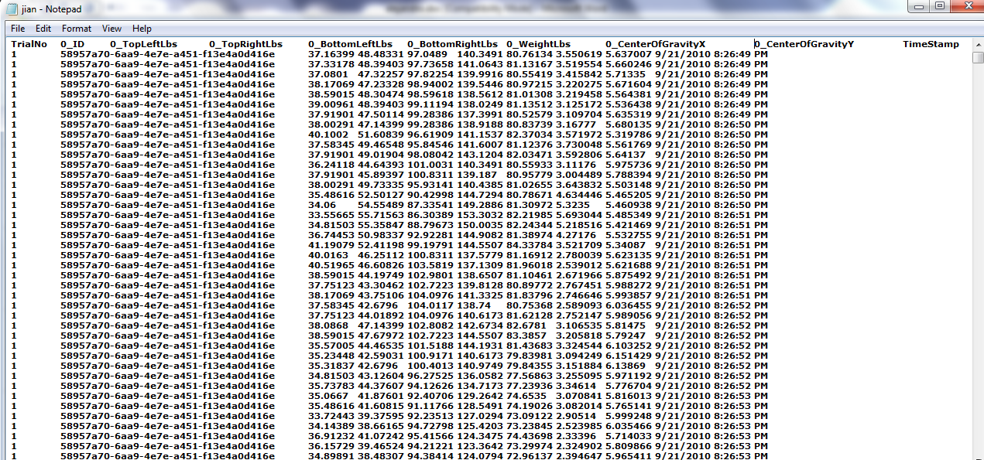

Methodology

The group gathered 7 participants, (different from the 10 participants that were in the actual experiment process) graduate students aged 25-31 at the Department of Information Systems and Computer Science of Ateneo de Manila University. Each were asked to sit comfortably on the Wii Balance Board. Once ready, the participants were asked to demonstrate seven postures: upright, lean forward, lean backward, lean forward left, lean forward right, lean backward right, lean backward left. The group recorded the postures using the WiiMote Interface (Figure 1).

Figure 1. WiiMote Interface
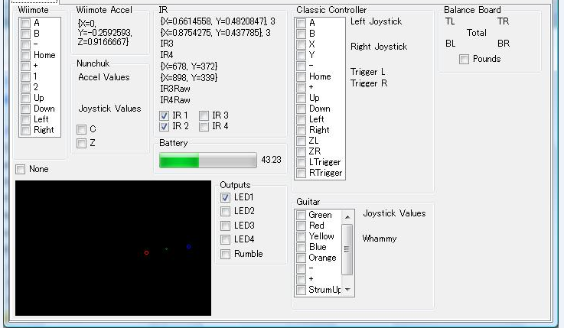

WiiMote produced a log file (shown in Figure 2) that contains columns for the TrialNo (trial number), 0_ID (log ID), 0_TopLeftLbs (weight of the participant in pounds at the top left side of the Wii balance board), 0_TopRightLbs (weight of the participant in pounds at the top right side of the Wii balance board), 0_BottomLeftLbs (weight of the participant in pounds at the bottom left side of the Wii balance board), 0_BottomRightLbs (weight of the participant in pounds at the bottom right side of the Wii balance board), 0_WeightLbs (total weight in stance area), 0_CenterOfGravityX (the paticipant’s center of gravity x position over stance area), 0_CenterOfGravityY (the paticipant’s center of gravity x position over stance area), TimeStamp (the date and time of the log). The WiiMote software sampled the board at 9 times per second.
The group added an additional column named Position to the raw log file that would indicate the posture that was done by the participants in a uniform interval of 20 seconds. This means that there are 180 samples for each posture.

The information gathered were fed to WEKA. The WEKA then, using J48, created a decision tree and confusion matrices, and returned the calibrated data that can be used as reference for the information (the sitting positions) that will be gathered from the actual participants.

Based on the resulting model from WEKA, a program was created on Visual Studio. Net. The program will be used to determine the sitting positions of the actual participants from the data gathered by the WiiMote.

Figure 3. Code Snippet, Determine Sitting Positions
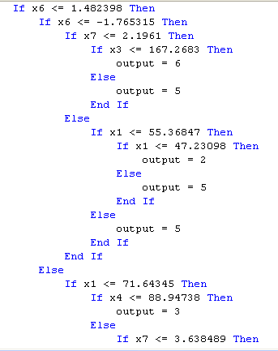

Testing the Model
To be able to test the model that was created, the group gathered 10 participants ages 18 to 39 studying different courses at School of Science and Engineering in Ateneo de Manila University.
Since only one Wii Balance Board has been used, the participants played the game one at a time, with each given 15-20 minutes to play the game consuming 3 levels of the whole gaming process (shown in Figure 4).

Figure 4. Participant sitting on the Wii Balance Board while playing Plants vs Zombies
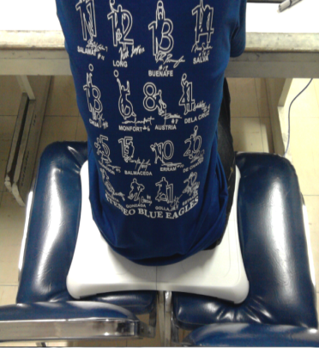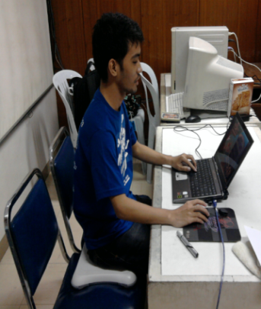
The WiiMote log was fed to the program to determine the sitting position of the participants. Table 1 was created to automatically code the affect of the participants; this is based on the affective description taken from D’Mello and Graesser [1]:
- Delight –sitting on the edge, leaning forward;
- Frustration –leaning forward right, leaning forward left, slouching, and resting the chin on his/her palm, sitting upright;
- Neutral – other; did not appear to be displaying any of the affective states above, or the student’s affect could not be determined for certain.

Table 1. Determining the Affect based on the Posture
Position | Posture | Affect
1 | Upright | Delight
2 | Lean forward | Delight
3 | Lean backward | Frustration
4 | Lean forward left | Frustration
5 | Lean forward right | Frustration
6 | Lean backward right | Neutral
7 | Lean backward left | Neutral

RESULTS

Results from the Wii Balance Board
The Visual Basic program was then used to label the data from the Plants vs. Zombies test subjects. For every line of the log, the program added a column to identify the posture of the participants. It then gave the generated result (sitting position) of the participant first affective state per time slice of 20-seconds (Figure 5) and the total number of occurrences in each position (Figure 6). All the results were automatically saved in the same folder of the application and named as result.txt.
Figure 5. Sample Result of a Participant’s Affect in
20 second Time Slice
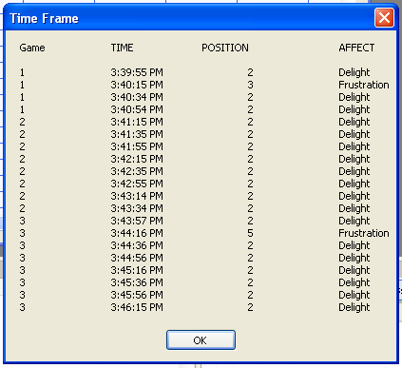
Figure6. Sample Summary Result of a Participant’s Affect
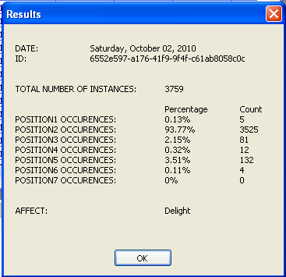

Table 2 shows the occurrences of delight and frustration for each of the participants. For participants who experience delight tend to lean forward when playing Plants vs Zombies while participants who experience frustration tend to lean backward and lean forward left.
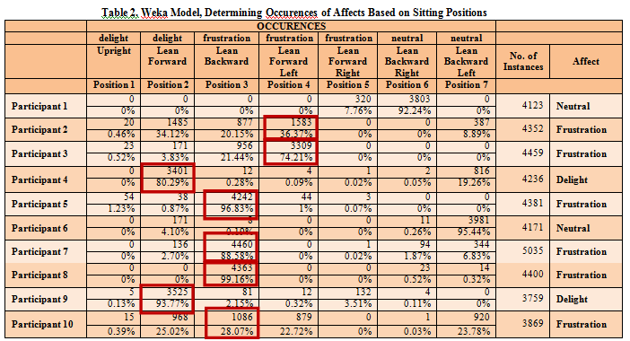

CONCLUSION
The affect of a participant can be determined by the posture that was detected by the Wii Balance Board. But still, further data should be gathered and collected.

ACKNOWLEDGEMENTS
The researches thanks Sidney D’Mello for permitting them to use the Wii Balance Board (Modified WiiMote) data capture software. The researches also thank the Department of Science and Technology for the grant entitled “Design of Affect-Sensitive Interfaces”.

REFERENCES

D'Mello, S., and Graesser, A. (2010). Mining Bodily Patterns of Affective Experience during Learning . In A. Merceron, P. Pavlik, and R. Baker (Eds.), Proceedings of the Third International Conference on Educational Data Mining (pp. 31-40).

Moon L.B., Johnson, D., Kadhiresan, V., Franke, K., and Tait, B. June 21, 2007. Posture Sensor. Accessed on 11 January 2011 from http://images2.freshpatents.com/pdf/US20070142868A1.pdf

D’Mello S, Picard R, and Graesser A. Towards An Affect-Sensitive AutoTutor.IEEE Intelligent System 22,4 (July 2007), 53-61. DOI= 10.1109/MIS, 2007.79 http://dx.doi.org/10.1109/MIS.2007.7.9

S. Mota and R.W. Picard (2003). Automated Posture Analysis for Detecting Learner's Interest Level. Workshop on Computer Vision and Pattern Recognition for Human-Computer Interaction, CVPR HCI, June, 2003

Olney M, and D’Mello S. A DIY Pressure Sensitive Chair for Intelligent Tutoring System. Intelligent Tutoring Systems Lecture Notes in Computer Science, 2010, Volume 6095/2010, 456, DOI: 10.1007/978-3-642-13437-1_113

Hall,M., Frank, E., Holmes,G., Pfahringer, B., Reutemann,P., and Witten, I. (2009); The WEKA Data Mining Software: An Update; SIGKDD Explorations, Volume 11, Issue 1.

Wii Balance Board Operations Manual. Nintendo. Accessed on 11January 2011 from http://www.nintendo.com/consumer/downloads/wiiBalanceBoard.pdf

PopCap Games, Inc.2010. Plants vs Zombies ReadMe. Accessed on January 11, 2011 from http://popcap.com/faq/pvz/1033/pc/readme.html#C

